Grocery App : Using Kotlin

BACHELOR OF TECHNOLOGY

IN

COMPUTER ENGINEERING

Submitted By:

NAME: ACHAL BODALKAR

INDEX

1.Introduction of the project

2. Problem statement and proposed solution

3.Project design

4.Hardware and Software Requirement

5. Output

6.Summary and further Work

7.Output

8. Bibliography

**Introduction:**

People today are very busy and tend to forget what they need to buy.This app allow the user to make a reminder list when a user is in the market, he/she will look up in the list and can buy whatever they want .

Problem Statement and Proposed Solution (Features of Application) :

● Allow users to make a checklist of items they wish to buy

● Organize into categories based on type of item such as groceries, clothing, apparel,electronics ● The user should be able to choose a priority High,Medium or Low for each item

**Project Design:**

### MVVM architecture in android is used to give structure to the project’s code and understand code easily. MVVM is an architectural design pattern in android. MVVM treat Activity classes and XML files as View. This design pattern completely separate UI from its logic. Here is an image to quickly understand MVVM.

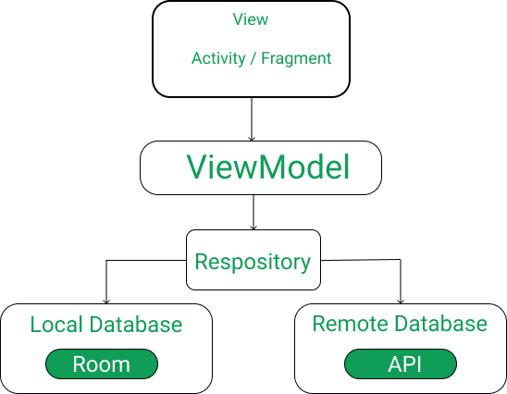

ROOM DATABASE

Room persistence library is a database management library and it is used to store the data of apps like grocery item name, grocery item quantity, and grocery item price. Room is a cover layer on SQLite which helps to perform the operation on the database easily.

RecyclerView:

RecyclerView is a container and it is used to display the collection of data in a large amount of data set that can be scrolled very effectively by maintaining a limited number of views.

Coroutines:

Coroutines are a lightweight thread, we use a coroutine to perform an operation on other threads, by this our main thread doesn’t block and our app doesn’t crash.

DAO Interface:

The Dao is an interface in which we create all the functions that we want to implement on the database. This interface also annotated with @Dao.

**Hardware And Software Requirement:**

Android studio.

**Summary and Further Work :**

The Grocery app was implemented successfully with most of the features specified in the project proposal. To improve the application I plan to implement the following enhancements:

● Additional feature to store favorite items/ recently added items so that user can quickly add frequently bought items.

● I plan to optimize the power usage further by making use of the accelerometer to calculate distances within a short radius using the device’s sensors rather than relying on GPS.

OUTPUT:

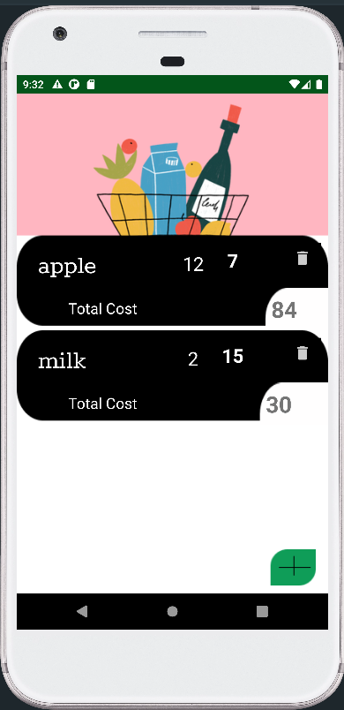

**Bibliography:**

1. http://www.vogella.com/tutorials/AndroidSQLite/article.html

2. https://developers.google.com/maps/

3. http://www.research.att.com/articles/featured_stories/2011_03/201102_Energy _efficient?fbid=bj7IxEKH3ZE

4. http://www.techrepublic.com/blog/software-engineer/a-quick-tutorial-on- coding-androids?accelerometer/472/

5.[How to Build a Grocery Android App using MVVM and Room Database? - GeeksforGeeks](https://www.geeksforgeeks.org/how-to-build-a-grocery-android-app-using-mvvm-and-room-database/)